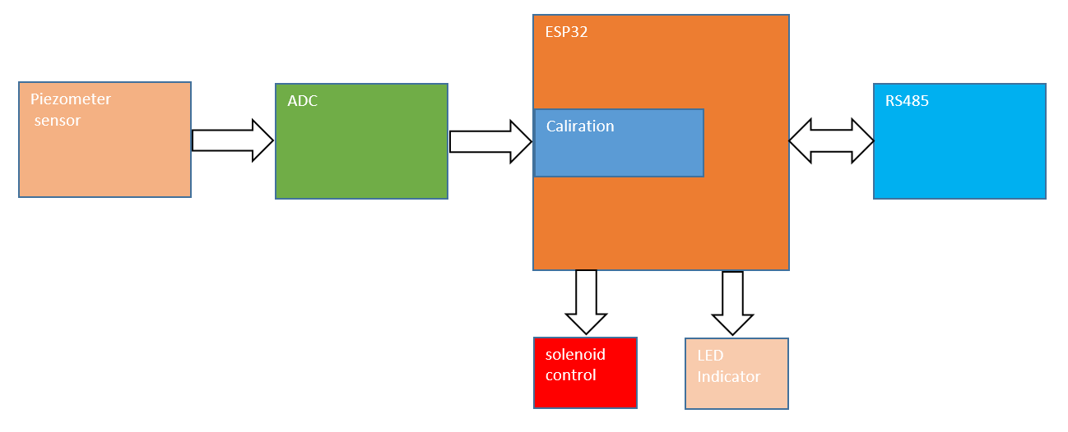
Piezometer Software design
The system operates with the valve normally open to avoid pressure buildup in the pipe. When the master system sends a command (RS485 ASCII), the module closes the solenoid valve to accumulate pressure for 24 hours.
After this period, a measurement is taken with statistical data cleaning, and the value is sent to the master. The valve is then reopened, and the accumulated water is discharged.
And one LED indicator indicates the states 'Pressure Accumulation' or 'Free', and to consider intermediate readings to prevent overpressure on the sensor.
1.COM configuration：
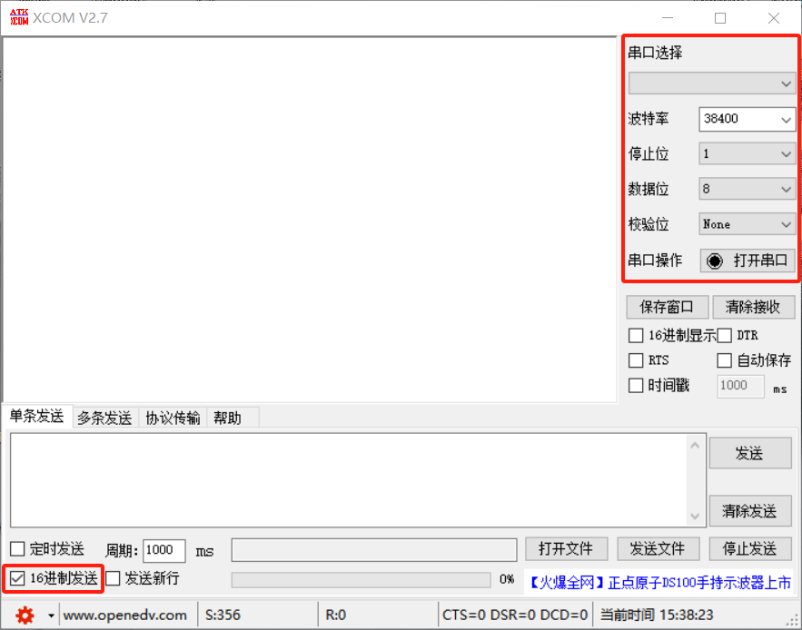
- Select the COM port
- Baud rate 38400
- Stop bit 1
- Data bit 8
- Calibration bit None
2.Piezometer control command：
- Pressure Accumulate start command：24 09 00 00 41 01 4B 0D 0A
Pressure Accumulate stop command：24 09 00 00 41 00 4A 0D 0A
Pressure Accumulate control reply command ：24 08 00 57 61 C0 0D 0A
When the piezometer device receive the pressure accumulate start command from the control device, the piezometer device starts ADC sampling and close solenoid valve. The LED changes to Pressure accumulation state.
When the piezometer device receive the pressure accumulate stop command from the control device, the piezometer device stop ADC sampling and open the solenoid valve. The LED changes to free state.
When the piezometer device start or stop ADC sampling, it will transmit the feedback command to the control device.
- Accumulate start command
NO. | Data | Bytes | Description | Data type | remark
1 | Start ID | 1 | 0X24 | UChar
2-3 | length | 2 | 0X0009 | UShort
4 | Sender ID | 1 | 0X00 | UChar
5 | CMD | 1 | ‘A’（0X41） | UChar
6 | control | 1 | 0x01 start accumulate  0x00 stop accumulate | UChar
7 | check sum | 1 | Check sum of 2-6 bytes | UChar
8-9 | End | 2 | 0X0D and 0X0A | UChar
- Accumulate control feedback command
NO. | Data | Bytes | Description | Data type | remark
1 | Start ID | 1 | 0X24 | UChar
2-3 | length | 2 | 0X0008 | UShort
4 | Sender ID | 1 | ‘W’（0X57） | UChar
5 | CMD | 1 | ‘a’（0X61） | UChar
6 | check sum | 1 | Check sum of 2-5 bytes | UChar
7-8 | End | 2 | 0X0D and 0X0A | UChar

- Pressure data feedback command：24 0B 00 00 62 00 00 00 00 57 0D 0A
When the piezometer is in sampling status, it will transmit the pressure data to the control device per second。
- pressure data feedback command
NO. | Data | Bytes | Description | Data type | remark
1 | Start ID | 1 | 0X24 | UChar
2-3 | length | 2 | 0X000B | UShort
4 | Sender ID | 1 | ‘W’（0X57） | UChar
5 | CMD | 1 | ‘b’（0X62） | UChar
6-9 | Pressure | 4 |  | UChar
10 | check sum | 1 | Check sum of 2-5 bytes | UChar
11-12 | End | 2 | 0X0D and 0X0A | UChar

